# 

# **Department of Computer Science and Engineering Islamic University of Technology (IUT)** A subsidiary organ of OIC

# **Laboratory Report**

# CSE 4412: Data Communication and Networking Lab

## 

## **Name: Khalid Hasan Ador Student ID: 210042102 Section: B Semester: 4th Academic Year: 2022-2023**

**Date of Submission: 22/03/24**

### **Title:** Configuring Switch Port Security and Switch Port Analyzer (SPAN) in Cisco Devices

### **Objective**:

1. Describe the concept of Switch Port Security
2. Explain importance of Switch Port Security in securing an organization
3. Configure Switch Port Security in CISCO devices
4. Use Switch Port Security feature to achieve varying degrees of protection
5. Describe the concept of port mirroring
6. Implement port mirroring using Cisco Switch Port Analyzer (SPAN)
7. Explain use cases of SPAN in real-life

### 

### **Devices/ software Used**:

* + - 1. Cisco Packet Tracer

### **Theory:**

**Port Mirroring:**

It mirrors traffic from one port to another port. The packets from one port are copied and sent to another port, where a packet analyzer is connected. This packet analyzer can be a purpose-built hardware or it can be an application like Wireshark or an Intrusion Detection System (IDS) running on a host device. Technically, these are Ethernet frames which will be mirrored.

**Local SPAN:**

When traffic on a switch port is mirrored to another port on that switch, then it's Local SPAN.

### **Diagram of the experiment(s):**

*(Provide screenshot of the final network topology. Make sure to label the network components.)*

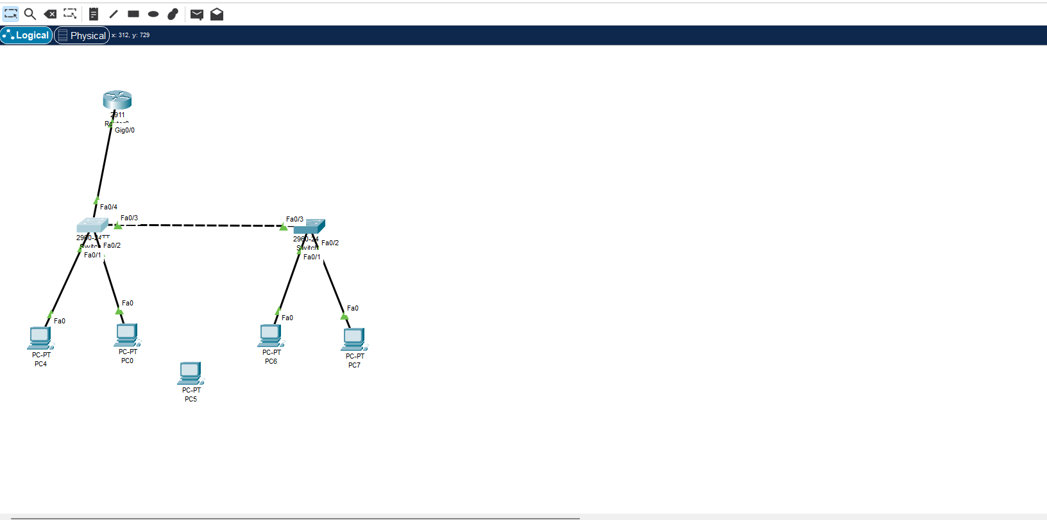

### **Working Procedure:**

***(****Explain in brief how you completed the tasks. Provide necessary screenshots of used commands for each task.)*

1. **Implemented the vlans:**

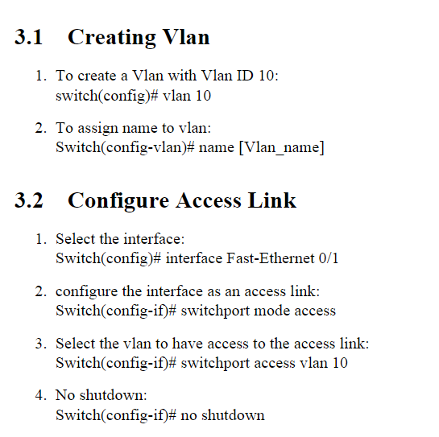

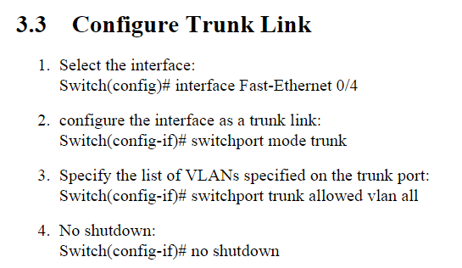

1. **Implemented Inter-Vlan Communication**

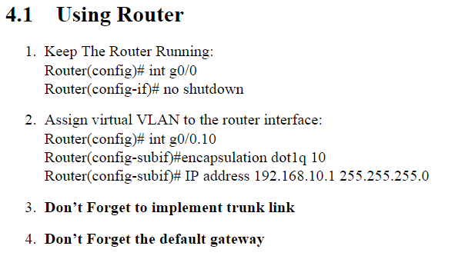

1. **Configured switch port security**

S1(config)# interface range f0/1 – 2

S1(config-if-range)# switchport port-security maximum 1

S1(config-if-range)# switchport port-security mac-address sticky

S1(config-if-range)# switchport port-security violation restrict

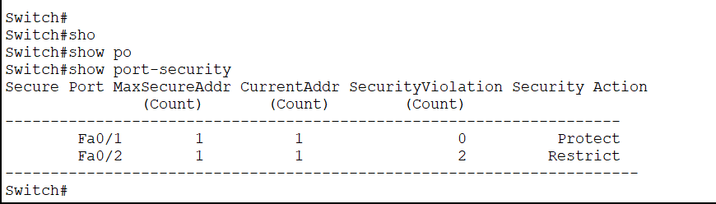

1. **Configured Span**

S1(config)# monitor session 1 source interface f0/2

S1(config)# monitor session 1 destination interface f0/1

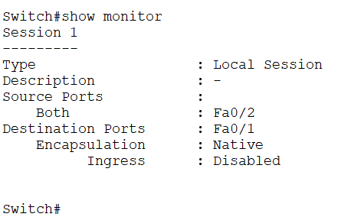

### **Observation**:

### **Challenges (if any):**